Bankfields Primary School

Draft Strategic Plan 2017-2020

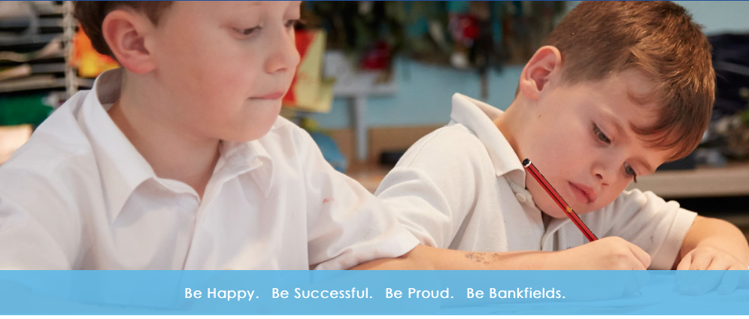

Contents | Page
Foreword by the Head Teacher and Governing Body | 3
Our School | 4
The Geography and Communities we serve | 4
Our Aims | 5
Our Key Strategic objectives | 6

Foreword from the Head Teacher and Governing Body

We are pleased to present our Bankfields Primary School Draft Strategic Plan for 2017 to 2022. We are very proud of what we have achieved over the last few years, and are keen to build on this work to maintain our trajectory of improvement and make our school the best that it can be for the benefit of all members of our school community.

The Head Teacher, Senior Leaders and Governors have worked together to identify our long-term priorities, considering our strengths and areas for improvement, and current and anticipated future educational trends.

We have put together this draft plan which includes 4 key objectives that we feel should guide our thinking and planning for the next 3-5 years.

We are sharing this document with our key stakeholders, parents, staff and children, as we value your views and are keen to receive your feedback on the plan. We will take any views expressed into account to make sure that we are focusing on the right areas in our plan.

We will review our Strategic Plan every year, to ensure that we are making progress against our objectives and that we are still focusing on the right priorities.

If you would like to submit any feedback, please complete and return the comments sheet to the school office no later than Friday 3rd March 2017. You can also send your views by email to the school office at office@bankfields.rac.sch.uk.

Mrs Patsy Petrie, Head Teacher
Mrs Liz Foster, Chair of Governors
And the Governing Body of Bankfields Primary School

Our School

Bankfields Primary School is an inclusive school at the heart of the Bankfields estate in Middlesbrough. We serve the children and families of Eston and the surrounding area. We ensure our children are educated in a safe, caring and stimulating environment where all children are valued as individuals and encouraged to reach their full potential. The pupils are supported by a team of hardworking, talented and dedicated staff who are passionate about enriching the lives of all our children by providing a broad and exciting curriculum as well as a wide range of extra-curricular activities.
The quality of teaching at Bankfields is good, and in March 2014, Ofsted judged that the progress children make in writing and maths is outstanding and good in reading. We aspire to build on our success and all staff are committed to ensuring that provision for our children is the best that it can be.
Strong relationships with parents are key to ensuring our children receive the best education possible. The school operates an “open door” policy where parents are welcome to come and discuss any concerns with the Head teacher or teaching staff, to ensure children are happy and successful in school. We run many family learning events throughout the year as well as a range of community events to encourage parents, carers and other family members to come into school to support children in their learning and to value the education they receive. We value the positive relationships we have formed with our parents.

Our Geography and the Communities we serve
Bankfields Primary School is situated within the Borough of Redcar and Cleveland in the North East of England. The school draws its children from the Eston ward.
Local Health profile data shows that 23.2% of children live in poverty in Eston Ward significantly worse than England’s average. In Eston Ward the child development at age 5, GCSE achievement, unemployment and long term unemployment are all significantly worse than the national average.
Child development (aged 5) is significantly worse than the national average. This perpetuates to achievement at GCSE, where children resident in Eston still do significantly worse than their national peers.
Data from Tees Valley Unlimited (TVU) 2013 showed the unemployment rate was 6.3%, the national unemployment rate is 3.8%. The long-term unemployment rate in Eston Ward is 17.7/1,000 residents, the national rate is 10/1,000.
Life expectancy in Eston Ward is significantly worse than the national average. The life expectancy of a male in Eston Ward is 74.5 years vs the 78.9 years national average. A female’s life expectancy is 78.9 years compared to the national average of 82.8 years.
The school has a higher than average number of pupils in receipt of free School meals at . The school falls within the Index of Deprivation band.

At Bankfields Primary School we aim to:
- create a warm, supportive and stimulating school environment in which children feel happy, safe and secure, and are eager to learn,
- develop positive relationships founded on mutual trust, respect and good example,
- ensure all pupils are encouraged and supported in reaching their potential as learners,
- provide all children with a broad, balanced curriculum relevant to their needs and abilities,
- develop children as caring sensitive and tolerant individuals who have a clear understanding of right and wrong,
- introduce children to a wide range of experiences and challenges which motivate and enrich their learning, now and in the future,
- have high expectation of all children in terms of learning and behaviour,
- value all children equally, upholding their rights regardless of gender, ability, disability, colour or race,
- promote a strong partnership with parents based on shared information and responsibility for children’s learning,
- serve the community well, encouraging and welcoming support and interest, and inspiring confidence in the work of the school.

Our Key Strategic Objectives 2017-2020

Objective 1 – Provide an excellent education for our pupils whilst developing life skills for the future
We will offer a broad and balanced curriculum, and continually improve our children’s attainment of the highest levels within the new National Curriculum, closing the gap to National Expectation for all groups of children including SEND and pupil premium children, by ensuring they make outstanding progress from increasingly very low starting points. At the same time, we will ensure that they are developing life and employment skills and knowledge that will enable them to succeed in secondary school, further and higher education and the world of work. We will raise the profile of those subjects where children may aspire to work in the future – computing, science, engineering, technology, and break gender stereotypes to encourage more girls to develop an interest in these areas.

Objective 2 – Continue to maximise the benefits of collaborative and partnership working

We will continue to work in Partnership with our neighbouring schools, to embed a secure, long-term collaborative structure that facilitates school to school support and improvement, efficient and effective shared use of resources and staff, strong and effective Governance, and shared accountability.

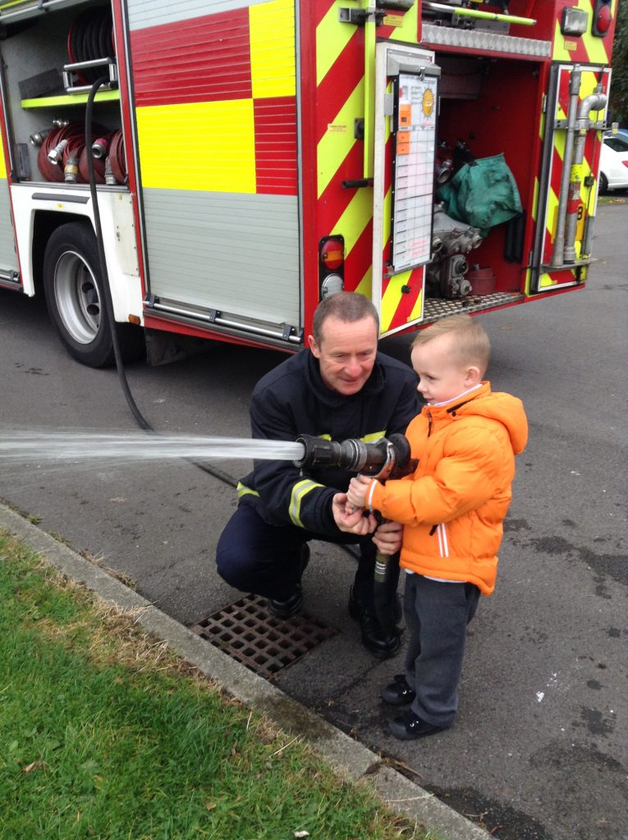

Objective 3 – Build a school for the future

We will build a school for the future - by making the best use of our school site and building, we will ensure there is sufficient capacity for all local children seeking a place at our school, and that the school facilities are upgraded and maintained to make them fit for purpose in supporting delivery of an excellent 21st century education for our children.

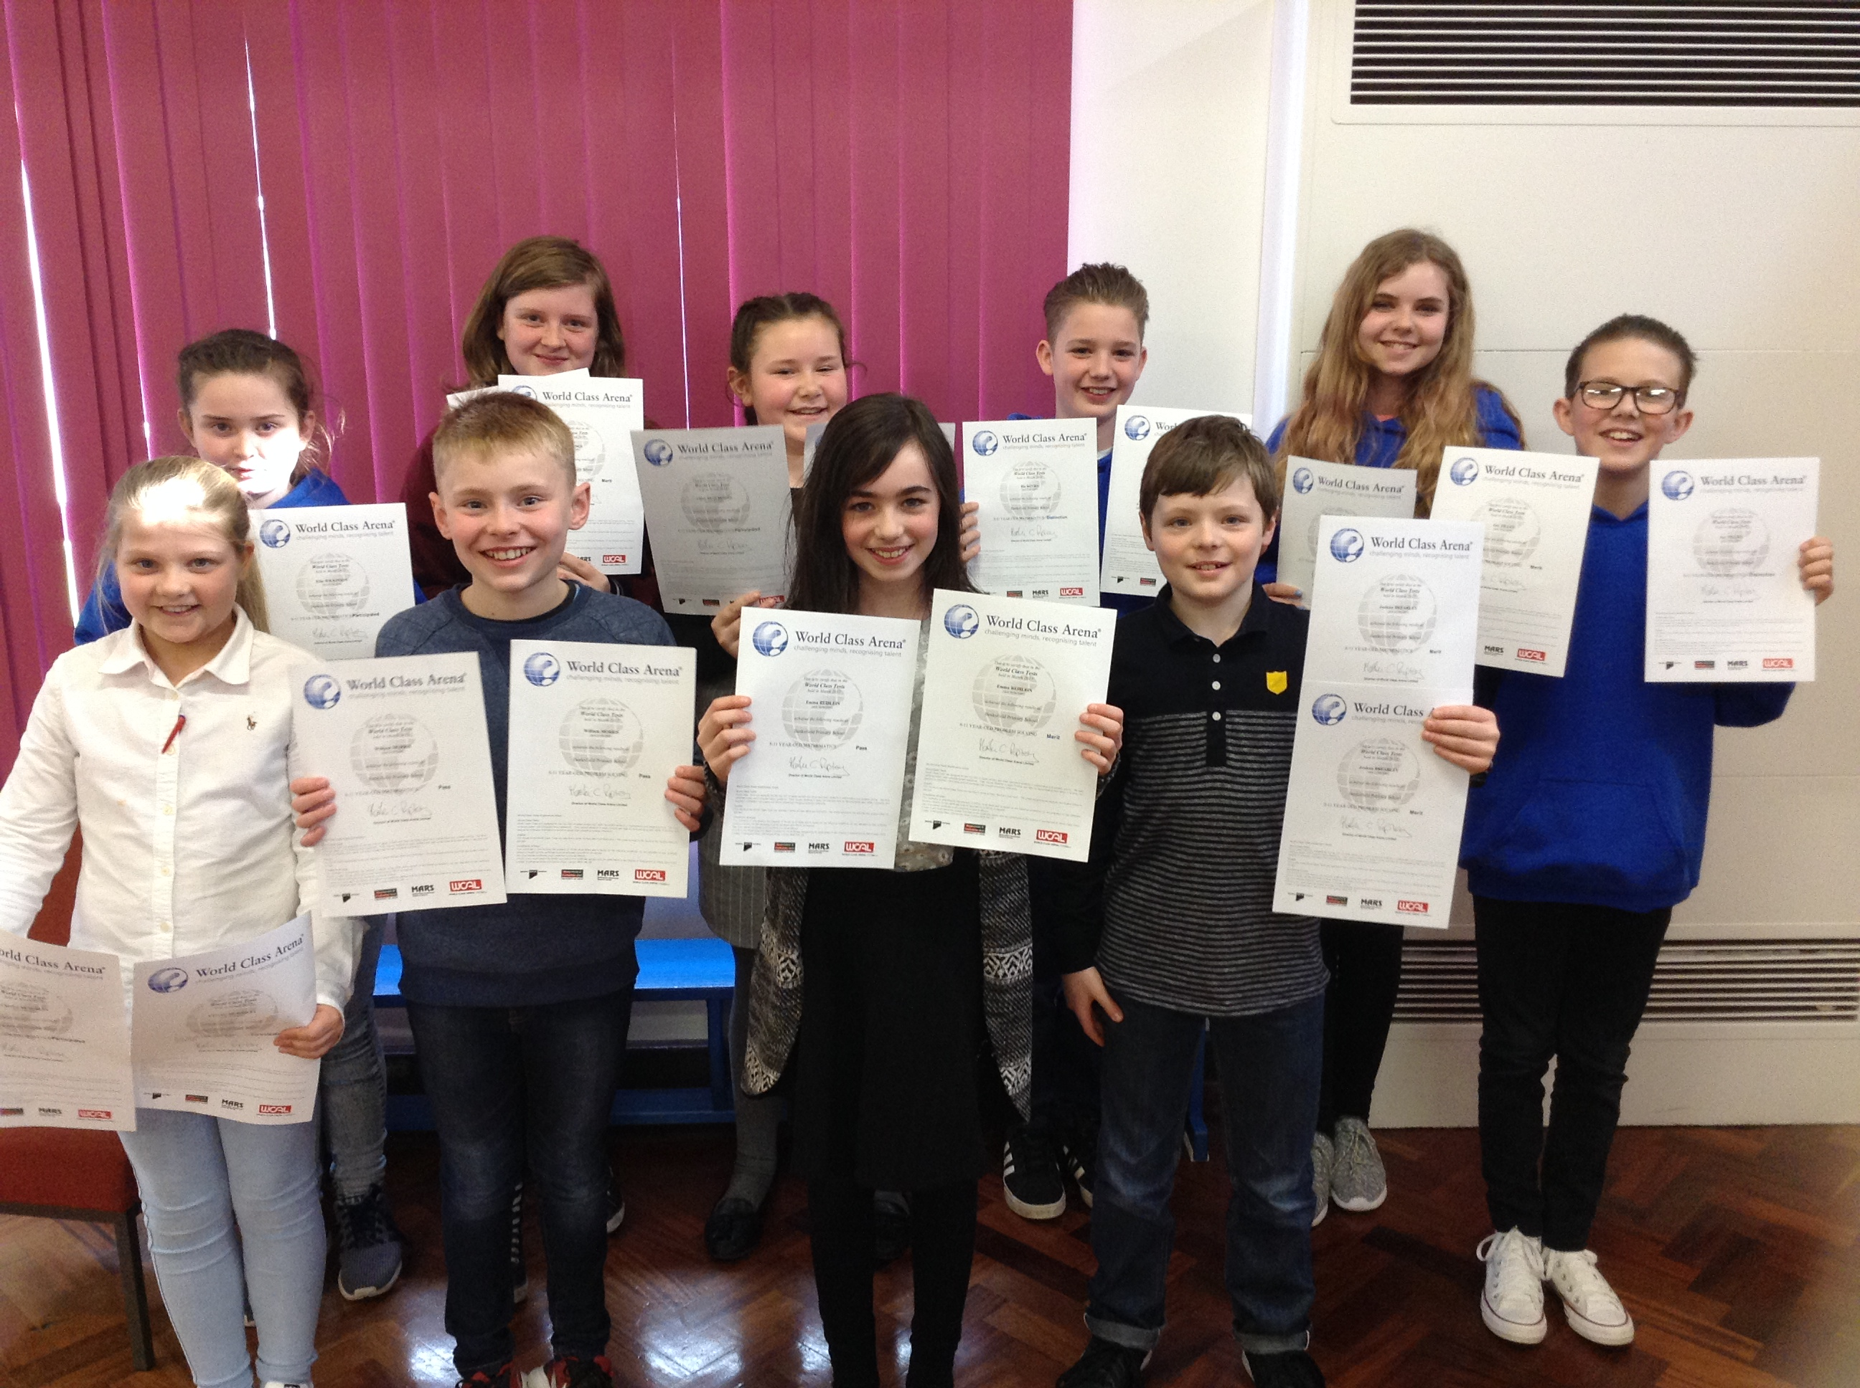

Objective 4 – Improve and enhance our financial and administrative systems

We will improve our financial management and control and overhaul our administrative support systems so that we are managing our budget efficiently and effectively and our administrative systems are streamlined and effective in supporting teaching and learning, staff, pupils and parents.

Bankfields Primary School, Mansfield Road, Bankfields, Middlesbrough, TS6 0RZ

Email: office@bankfields.rac.sch.uk
Website: http://bankfieldsprimary.co.uk
Bankfields Primary School – Draft Strategic Plan

Comments and feedback

If you would like to submit any comments on the draft plan, please complete this form and return it to the school office by Friday the 12th May 2017.

You can also send your views by email to office@bankfields.rac.sch.uk - please mark your email “Strategic Plan Feedback”

Do you agree with the 4 Key Objectives identified in the plan?

Are there any other areas that you feel we should be focusing on as a school?

Do you have any other comments or views?

You can include your name and contact details here if you wish, however, please leave this blank if you would prefer not to.

Name:_____________________________________________________________

I am a *Parent/ Staff member/Pupil/Other (please specify) ____________________
delete as applicable *

