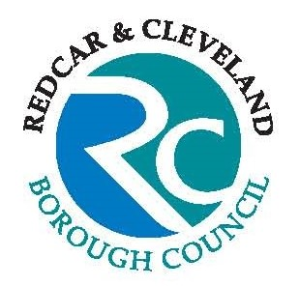 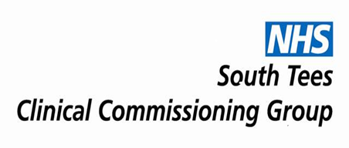

**Please come along to our**

SEND

DROP IN SESSIONS

**Which we are hosting at various venues across Redcar and Cleveland over the next 6 months:**

**Loftus Family Hub* on 18th July 2019, from 12pm – 2pm**

**Grangetown Family Hub* on 12th September, from 12pm – 2pm**

**Saltburn Family Hub* on 11th October 2019, from 11.30am – 1.30pm**

**Tuned In! Redcar on 20th November 2019, from 10am – 12pm**

**This will be an opportunity to chat with members of the Local Authority SEND Team, The Children with Disabilities Social Work team and the NHS Designated Clinical Officer (DCO) who will be on hand to provide general advice, support and guidance.**

**We would also welcome your ideas and suggestions for improving consultation and services across the local area.**

***(*The Family Hubs are our new names for what were previously called our Children’s Centres; their locations haven’t changed)***