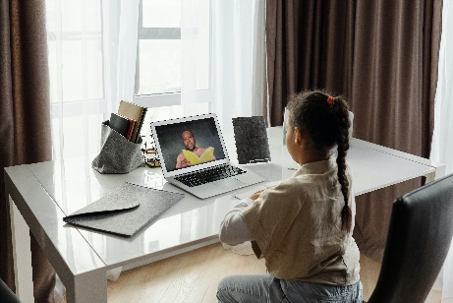
Bankfields Primary School

Remote Learning Offer

2020-2021

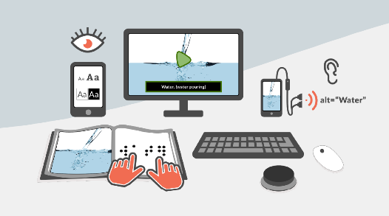
Bankfields primary School
Remote Learning Offer - Rationale
The staff at Bankfields School have put together a remote learning offer for all children across the school. The purpose of this is to ensure that there is a robust contingency plan in place to ensure all children have access to quality education in the event of further lockdowns, bubble closures or self-isolation.
During the school closure period, between March and September, children have missed a significant amount of their learning as well as personal development opportunities. The staff at Bankfields are determined to ensure that they are doing everything they possibly can to support children to catch up on lost learning as well as meeting their social and emotional needs. Therefore, remote learning will also be used as part of our ‘catch up programme’. This is to support children to catch up on lost learning and to develop their skills and knowledge in a range of subjects as well as activities to support their mental health and wellbeing.
We recognise that some children are able to cope more than others with larger amounts of home learning and it is important that children do not become overwhelmed with the additional workload. Although we would encourage parents to support children to complete as many tasks as possible in order for them to reach age-related expectations in key areas, it is important that the work is manageable for the children.
This remote offer is what school will put in place for all children, but it is not compulsory for all tasks to be completed each week. It is important that parents and teachers engage with each other to determine the appropriate amount of home learning for each child, which will offer appropriate challenge, not allow them to ‘opt out’ but does not cause unnecessary anxiety.
The school is part of the DfE ‘Get help with technology programme’ to support disadvantaged pupils with remote learning in the event of a bubble closure. In addition, alternative arrangements will be made for those children who do not have access to an electronic device or the Internet. In these cases, hard copies of work will be sent out to the child, contact will be made by the class teacher each week via telephone call to discuss any difficulties the child is facing and 1;1 support will be planned in for the child’s return to school.
The programme that school has opted to use for remote learning is Seesaw. Teachers will be demonstrating how to use this regularly in school to ensure children are able to easily access it at home. Regular updates will be given to children and sent out to parents to address any teething problems. However, as this is a new way of working for staff, parents and children, there may be a few issues initially and we would ask for parents to be patient and to stick with it while we all become au fait with this new way of working.

Whole school remote learning offer
Bubble Closure/self-isolation Key Stage 1 & 2

 | English | Maths | Curriculum
Teacher isolating | Teaching as per normal school day. Pre-recorded voice message for each lesson. This will avoid any technological issues, which could occur if live via Teams, which would result in lost learning. Email the person covering the day before with all Smart Notebooks and resources needed for the next day. Teachers to remain live on chat via Teams during each lesson. If any technological issues occur, be available to converse via email for the duration of each lesson.
Bubble closure/lockdown | Pre-recorded message via Seesaw with a phonics/English activity to complete on seesaw | Pre-recorded message via seesaw with a maths activity to complete on seesaw | Pre-recorded message via Seesaw with an activity to complete on seesaw alternating between history/geography/science
Child isolating | Pre-recorded message via Seesaw with a phonics/English activity to complete on seesaw | Pre-recorded message via Seesaw with a maths activity to complete on seesaw | Pre-recorded message via Seesaw with an activity to complete on seesaw alternating between history/geography/science

Practise of remote learning in school
Regular teacher demonstration of accessing Seesaw
Teachers to practise using Teams
TAs to practise speaking to teachers via Teams

Foundation Stage
Bubble Closure/self-isolation Foundation Stage
NURSERY

Individual child self isolating | Bubble in lock down | Teacher in isolation
- Send the previous day activities pack (electronically – Seesaw) or paper version available to collect from office. | - Am / pm session greeting  - Rhyme time or story input  - One daily activity. | - Other staff members will teach from teachers planning – delivery of activities in the setting.  - Teacher story time / session input via video link/live-streaming input.
RECEPTION
Individual child self-isolating | Bubble in lock down | Teacher in isolation
- Send the previous day activities pack(electronically – Seesaw) or paper version available to collect from office:  - Phonics group activity  - Number group activity  - Curriculum activity | 3 daily activities – ability differentiated.  - Morning greeting from teacher  - Phonics session input and activity  - Number input and activity  - Curriculum input/activity | - Other staff members will teach from teachers planning – delivery of activities in the setting.  - Teacher isolating would deliver through video links or live streaming to class – TA to facilitate

Whole school remote learning offer – catch up and consolidation
Year Group | Activities | Frequency
Nursery | Phonics/rhyme time/creative activity to complete with parents at home | 1 x weekly  Sent out on a Friday
Reception | 1 x Phonics activity  1 x Number activity or curriculum activity | 2 x weekly activities  Sent out on a Friday
Year 1 | 1 x phonics and sentence writing activity  1 x maths homework – catch up learning to fill gaps from EYFS and to consolidate learning | 2 x weekly activities  Sent out on a Friday
Year 2 | Phonics activity  Maths activity  Curriculum activity/alternating between science, history and geography | 1 of each per week. Sent out on a Friday to be completed by the following Thursday
Year 3 | - Weekly task for maths and English sent remotely via Seesaw for consolidation and pre-learning.  - Tasks for science and the other foundation subjects will be sent via Seesaw as appropriate for pre-teaching and consolidation of Y3 topics.  - All children have access to TT Rockstars and can access this at home to practise their times tables.  - All children to be able to access Accelerated Reader quizzes at home.  - Thrive practitioner to send out Thrive activities to Thrive pupils. | - Maths and English weekly. Sent on a Friday.  - Science and foundation subjects as appropriate.  - Accelerated Reading to be completed at least 3 times per week at home.  - Thrive tasks sent weekly.
Year 4 | - Weekly task for maths and English sent remotely via Seesaw for consolidation and pre-learning.  - Tasks for science and the other foundation subjects will be sent via Seesaw as appropriate for pre-teaching and consolidation of Y3 topics.  - All children have access to TT Rockstars and can access this at home to practise times tables.  - All children to be able to access Accelerated Reader quizzes at home.  - Thrive practitioner to send out thrive activities to Thrive pupils. | - Maths and English weekly. Sent on a Friday.  - Science and foundation subjects as appropriate.  - Accelerated Reading to be  completed at least 3 times per  week at home  - Thrive tasks sent weekly.
Year 5 | - Weekly assignments for maths, English and science sent remotely via Seesaw, to practise key skills and missed concepts usually taught in Y4 and for pre-teaching activities to help children to catch up rapidly.  - When appropriate links sent via Seesaw to Espresso and Purple Mash to support and embed learning in other foundation subjects.  - 3 x 20 minutes of RM Maths per week.  - 3 x 10 minutes of TT Rock Stars per week.  - 12 targeted readers to complete one vocab quiz and five texts per week on Reading Plus computer program to improve reading efficiency, speed and comprehension levels.  - All children to be able to access AR quizzes at home. Children not on Reading Plus, to have an AR book for their home reader.  - Thrive practitioner to send out Thrive activities to Thrive pupils.  - WP to send out a weekly mindfulness activity to Y5 pupils. | - 3 assignments per week for core subjects  - 3 per half term  - Weekly  - Weekly  - Daily Access  - Daily Access  - Weekly  - Weekly
Year 6 | - Weekly assignments for maths, English and science sent remotely via Seesaw, to practise key skills and missed concepts usually taught in Y5 and pre-teach activities to help children to catch up rapidly.  - When appropriate links sent via Seesaw to Espresso and Purple Mash to support and embed learning in other foundation subjects.  - 3 x 20 minutes of RM Maths per week.  - 3 x 10 minutes of TT Rock Stars per week.  - 18 targeted readers to complete one vocab quiz and 5 texts per week on Reading Plus computer program to improve reading efficiency, speed and comprehension levels.  - All children to be able to access AR quizzes at home. Children not on Reading Plus, to have an AR book for their home reader.  - Thrive practitioner to send out Thrive activities to Thrive pupils.  - VC to send out a weekly mindfulness activity to Y6 pupils. | - 3 assignments per week for core subjects  - 3 per half term  - Weekly  - Weekly  - Daily Access  - Daily Access  - Weekly  - Weekly

